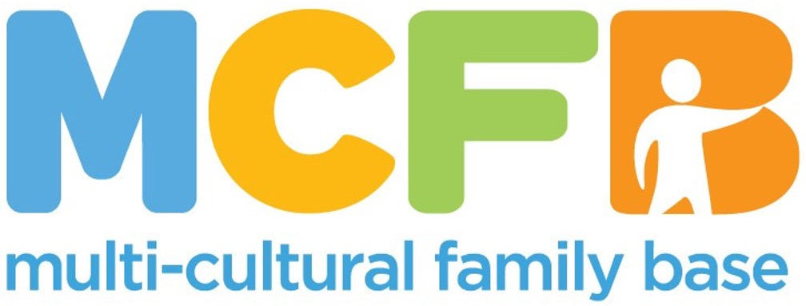

**JOB PACK**

This is a pack that gives the job description and other information about our organisation. In order to apply, please send a cover letter and CV to [hello@mcfb.org.uk](mailto:hello@mcfb.org.uk)

**ABOUT THE MULTI-CULTURAL FAMILY BASE**

**Founded with a commitment to social justice and inclusion in 1998, the Multi-Cultural Family Base (MCFB) is a leading organisation in Edinburgh dedicated to supporting diverse communities and enhancing the well-being of infants, children and families from all cultural backgrounds. MCFB provides essential community-based services, such as therapeutic group work, direct work, advocacy, and support to minoritised groups.**

**The Safe Haven project offers targeted support to people who have been displaced seeking asylum and refugee children, young people and their families, affected by trauma in their home country and in their journey to the UK. Our service aims to promote positive mental health, support children, young people and families to access resources, navigate systems and help families rebuild their lives, in order to develop a sense of stability, safety and trust. Our referred families include new migrants, those who are seeking asylum, refugees and survivors of human trafficking.**

**Our Values**

Multi-Cultural Family Base is an anti-racist and anti-oppressive organisation. We are passionate about promoting human rights, valuing diversity, providing equitable opportunities, and working in a way which is compassionate, responsive, respectful, and re-empowering. Multi-Cultural Family Base is committed to involving service users and stakeholders in co-production of service planning and provision.

We believe that community-based services for diverse families should be easy to access and able to respond to a wide range of needs. Our services include therapeutic groupwork and one-to-one casework. For more information go to: [www.mcfb.org.uk](http://www.mcfb.org.uk)

**ABOUT THE ROLE**

**Post Title:** Safe Haven Project Worker

**Hours:**  17.5 Hours (Potential for increase in hours)

**Pay:** £13,882.20

£27,764.40 FTE (SCP 25)

**Base:** 50 Coburg Street, Edinburgh, EH6 6HE, in the community as needed

**Reports to:** Safe Haven Project Leader

**EMPLOYEE PACKAGE & BENEFITS**

✓ Flexible Working & Family Friendly – We offer flexible working hours to accommodate families, childcare and caring responsibilities.

✓ Additional training is provided.

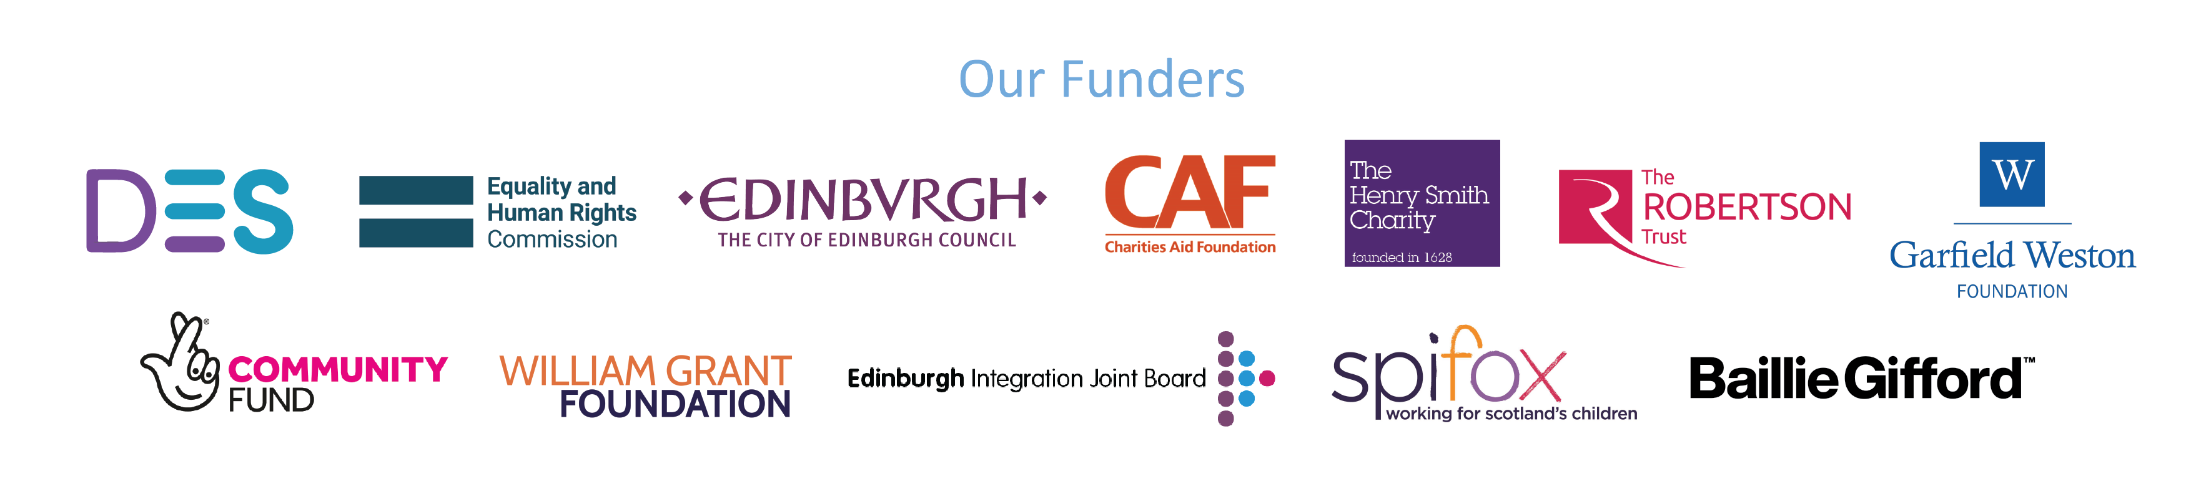

**JOB PURPOSE**

* To develop and deliver high-quality direct services to vulnerable refugee children and families referred to the project.
* To deliver these services in partnership with families and other agency partners (CEC Refugee and Migration team, schools, other voluntary agencies).
* To assist with developing the project and maintaining best practice in work with refugee families.

**KEY RESPONSIBILITIES**

* To provide a range of practical and emotional supports to children and families identified as being vulnerable
* To work with children and families in their homes as well as in the community or at MCFB
* To work with children, young people and their families to assess needs
* To provide one-to-one and group work support as appropriate to children, young people and adults.
* To ensure that the needs and progress of all service users are evaluated and recorded
* To provide progress reports on the work
* To maintain accurate and up-to-date records in accordance with MCFB’s Confidentiality and Recording Policy and other relevant policies
* To undertake initial assessments of service user’s well-being and to regularly review support in order to measure the impact of the provision
* To maintain communication with service users and to promote their involvement in the project
* To work at all times in a respectful, collaborative and open way with service users
* To liaise with statutory and voluntary agencies who provide services, including schools, health services, police and social work services
* To liaise with other agencies providing services to refugee communities
* To signpost service users to other agencies where appropriate
* To raise any potential child protection concerns with the Safeguarding Lead or appropriate Duty Senior.
* To promote the work of MCFB and disseminate information about available services
* Any other relevant duties which may be necessary

All employees at MCFB are expected to carry out any other duties that support our service users’ wellbeing or are necessary to support the effective running of the nonprofit.

**PERSON SPECIFICATION**

Function: Delivering a direct service to refugee children, young people and adults.

|  |  |  |  |
| --- | --- | --- | --- |
| **Criteria** | **Essential** | **Desirable** | **Assessment Method** |
| Education and Qualifications | - Degree level education | -Recognised Professional qualification (social work, community education, teaching, counselling / therapy).  -Certificate in Child Protection Studies  -Practice Teaching Award/PLQ(SS)  -Masters level qualification  -Post-qualifying training in therapeutic work with children and young people | -Application form  -Sight of qualifications |
| Experience and Knowledge | -Relevant experience in working with Refugees, asylum seekers and people from ethically diverse communities.  -Experience of individual and group work interventions with children, young people and their families  -Relevant experience of working within a counselling, community development or social care/ work role  -Knowledge and experience of evaluation strategies  -Knowledge and understanding of the impact of migration and trauma. | -Experience of strategic leadership  -Experience of working in the voluntary sector  -Experience in fund raising  -Knowledge of current best practice in work with refugees and asylum seekers.  -Experience in trauma-based work. | -Application form  -Interview  -References |
| Skills and Abilities | -Excellent communication skills (both verbal and written including report writing)  -Ability to communicate with children, young people and adults and build trusting relationships  -Ability to speak Arabic and / or a relevant community language  -Proven skills in assessing and managing risk  -Ability to network effectively with education professionals and colleagues in voluntary and statutory agencies  -Ability to facilitate individual and group work interventions with children, young people and adults  -Proven ability to organise own workload | -Confidence in electronic communication  -Skills in trauma-based work | -Application Form  -Interview  -References |
| Personal Qualities and Attitudes | -Strong ethical commitment to the aims and values of MCFB  -Commitment to anti-oppressive practice |  | -Application Form  -Interview  -References |

An updated PVG is required for the role. We will support the transition of the PVG to MCFB.